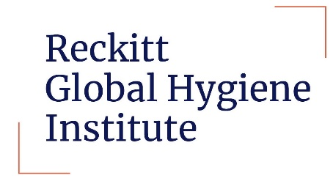
RGHI International Collaboration Award
FAQs
General questions
- What is the official title of the RGHI ICA?
Reckitt Global Hygiene Institute International Collaboration Award

- What is the purpose of the ICA?
The aim of the ICA is to support new and existing equitable collaborations between research institutions which produce new evidence and result in the translation of research findings into tangible advances in hygiene practices around the world.

- What types of projects are eligible for funding?
RGHI has a broad range of interest areas. These include projects which focus on:
- Exploratory research related to the links between hygiene and health
- Hygiene interventions and their impact on hygiene behaviours, norms and habits
- Implementation research to inform sustainable and scalable approach to hygiene behaviour change
- Research focused on hygiene policy and system strengthening, including economic analysis and evaluation
- Methodological research
Thematic areas of interest include:
- Planetary heath and climate change
- One Health e.g. Zoonosis, AMR
- Gender equity and social inclusion
- Hygiene behaviours beyond hand hygiene, e.g. Food hygiene
- What does it mean when it says half the institutions must be based in an LMIC?

Within any application half the institutions must be based in a recognised middle or low income country according to the World Bank (https://blogs.worldbank.org/opendata/new-world-bank-country-classifications-income-level-2022-2023)

For example, if 2 institutions were applying as part of a collaboration, 1 of them must be based in an LMIC, the other can also be based in an LMIC or a HIC.

If 3 institutes are applying, then 2 must be based in an LMIC, and 1 can be in an LMIC or HIC. There must always be at least 50% of applicants based in an LMIC.

Application process

- What is the application process for the ICA?
Application are open until 31st May 2023. The full list of application materials can be found in the application pack.

After applications close there will be a peer review process carried out by independent experts. An expert panel will be convened in September 2023 to select awardees. The formal announcement will be made at the RGHI Global Hygiene Summit in Singapore in December 2023.

- Which institutions are eligible for the grant?
Any recognised academic research institution or university is eligible for the grant.
- When is the deadline for submissions?
Application close at 5pm (EST) on 31st May 2023.

- How are grant recipients selected and notified?
After applications close there will be a peer review process carried out by independent experts. An expert panel will be convened in September 2023 to select awardees. The formal announcement will be made at the RGHI Global Hygiene Summit in Singapore in December 2023.

- Is there a limit to the amount of funding that can be requested?
Up to $750,000. The full list of eligible and non-eligible costs can be found in the ICA call specification.

Other questions

- How do I contact RGHI?
For queries relating to the International Collaboration Award you can email grants_admin@mail.rghi.org

- Is there an appeals process if my grant is not approved?
There is no appeals process for the ICA call. We will provide timely feedback on all applications, including justification for funding/not funding.

- What are the reporting requirements for grant recipients?
RGHI require grant holders to submit reports every 6 months for review. This is done through the Grant Management System.

** This document will be updated regularly to reflect additional questions and feedback, so please keep checking throughout the application process.

